Notes -

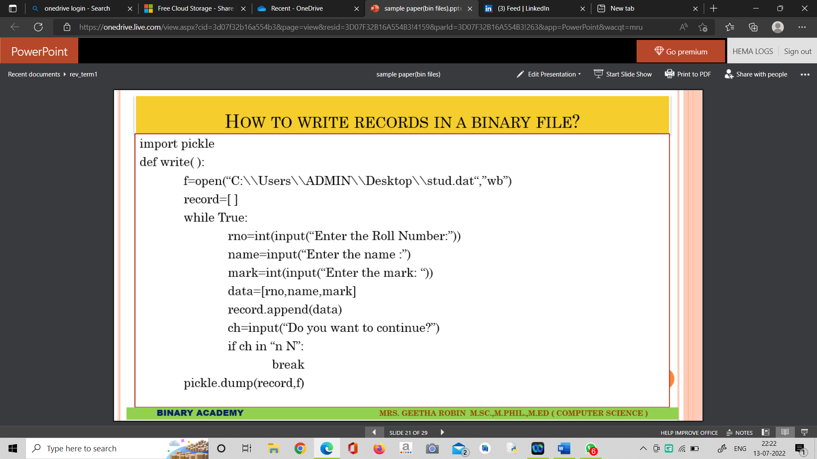

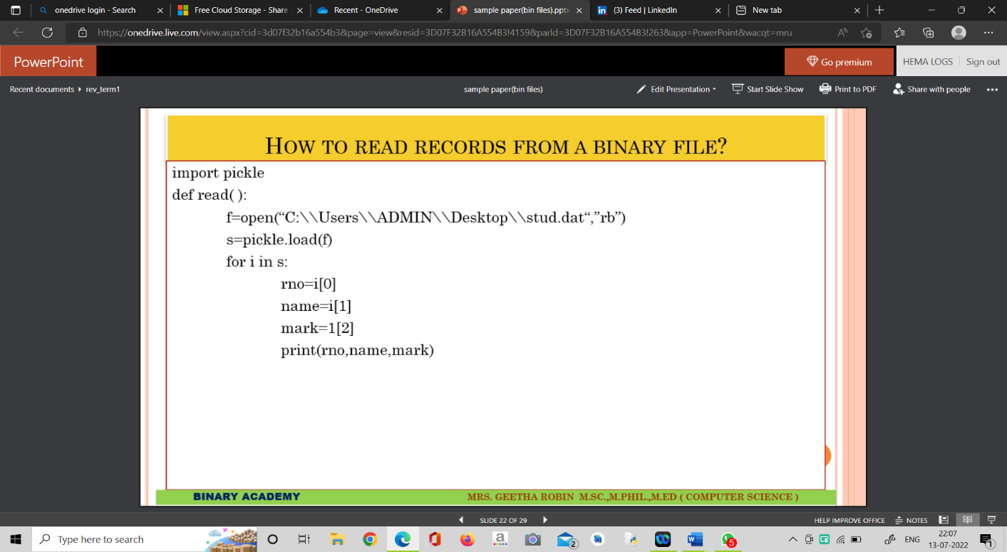

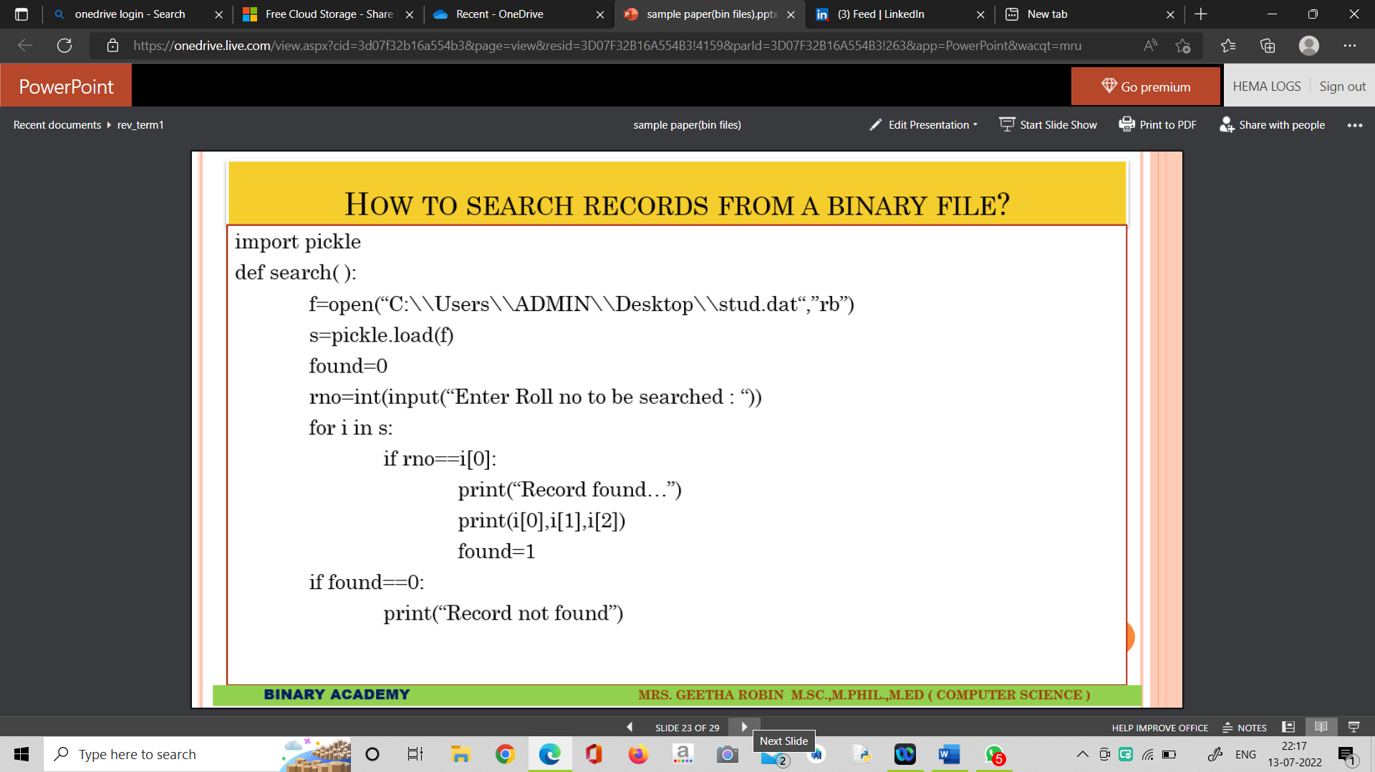

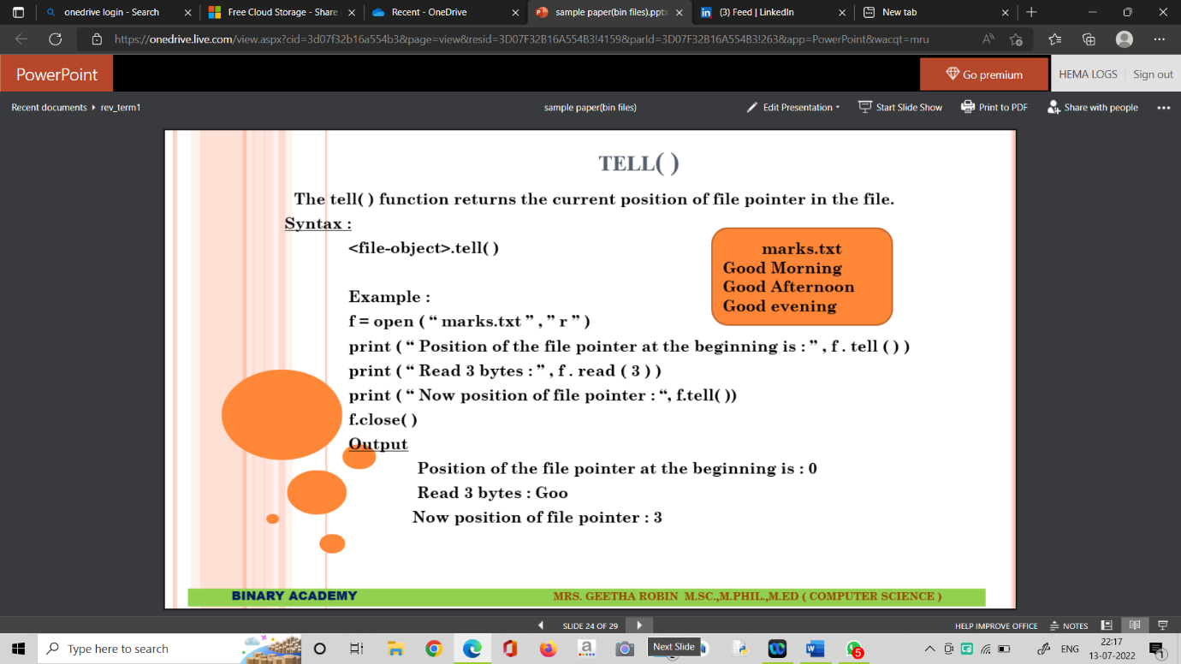

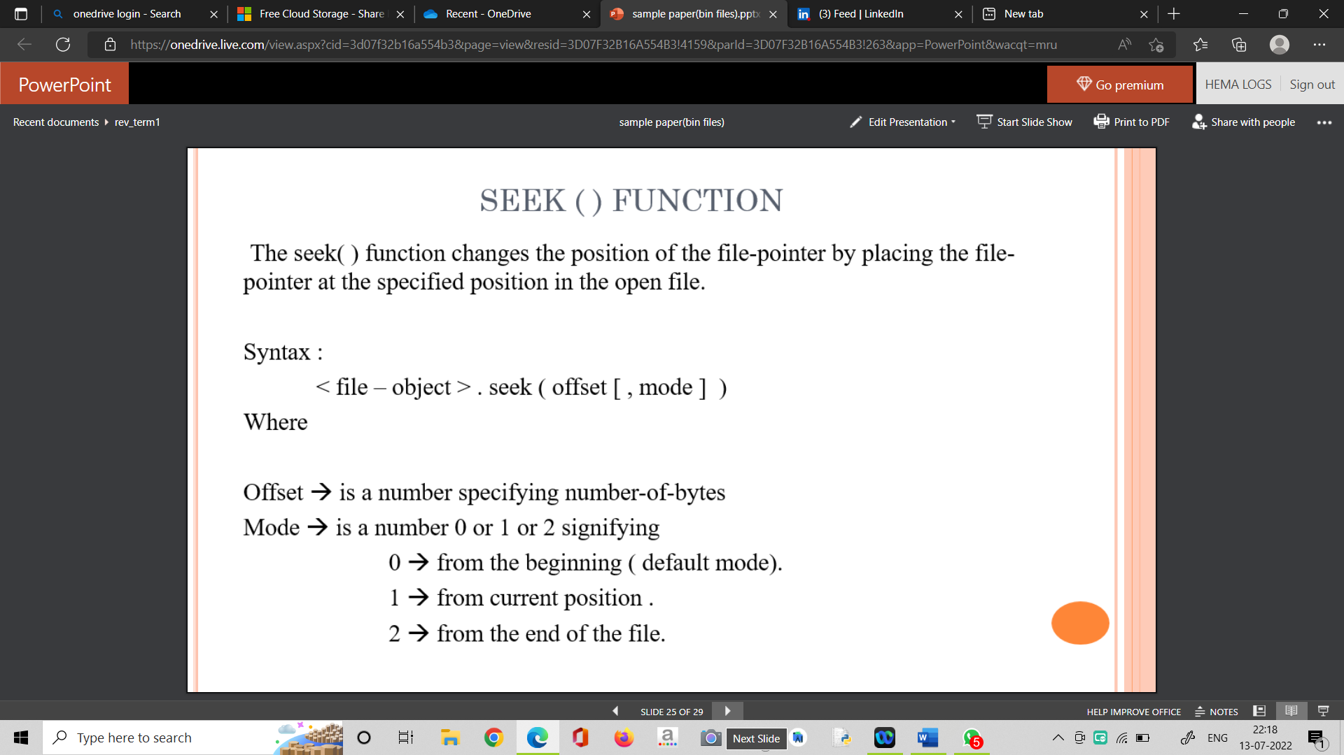

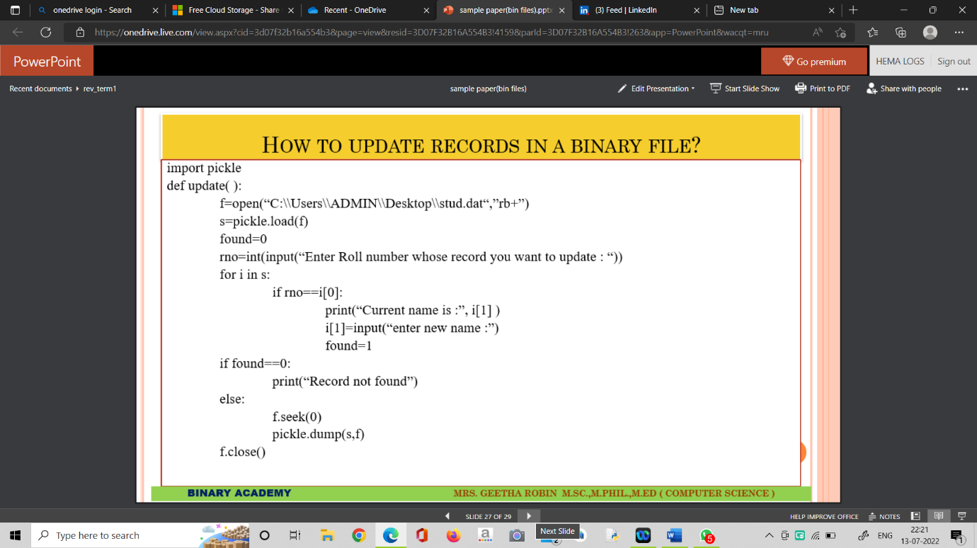

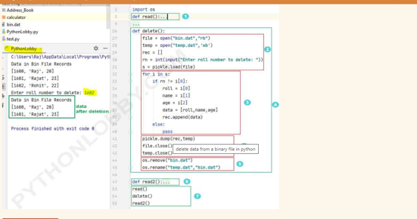

* **Step 1:**Here we have defined **read()**function, just to check the records available in our binary file. [**Read records from binary file**](https://pythonlobby.com/delete-records-from-binary-file-in-python/).
* **Step A:**In this block we have defined our complete delete method definition and sub divided the whole process of execution in four sub parts (2,3,4,5).
* **Step 2:**Here we have opened “bin.dat” in “**rb**” mode ie. reading mode. Also, a temporary file with the name “temp.dat” in “**wb**” ie. in write mode is opened.
* We have also declared an empty list **rec[]** which we will use later and also storing roll number from user input in “**rn**” variable that he wants to delete record. We are also reading the file using load method and storing that in file object “**s**“.
* **Step 3:**After getting the input roll number that the user wants to delete, at **step 3**each sublist is iterated and assign to “**i**” one by one. Now **if condition,** will check for, is the value inside “**rn**” .